**pwd :** Shows present working directory

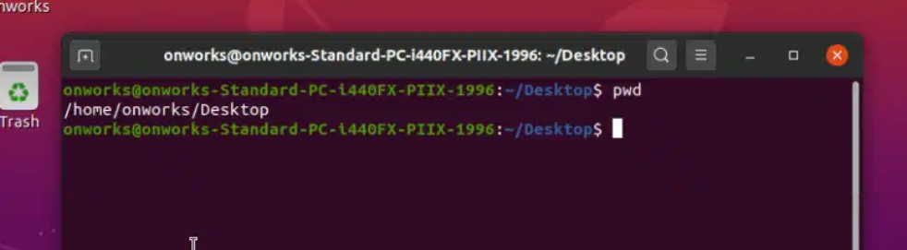

**dir :** Just prints all available directories in present working directory

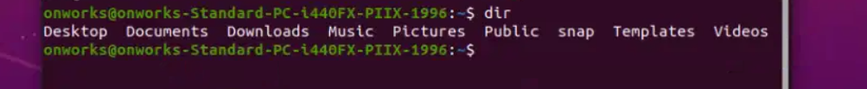

**ls:** used to list down all the directories and files inside working directory.

ls -al ----> shows detailed info of files and directories

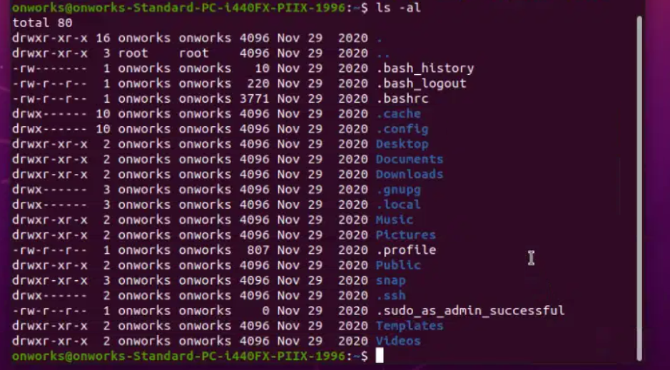

**ls -R --->** along with list of directories it also prints subdirectories of directory

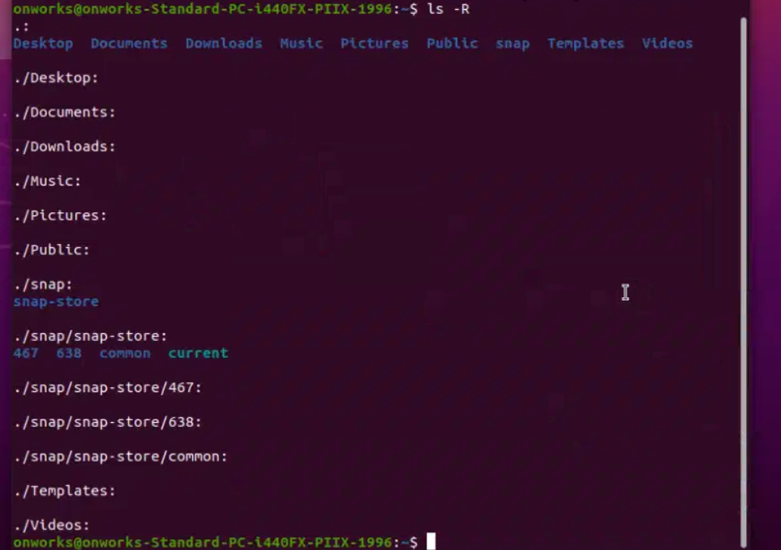

**ls -a --->** shows hidden files , hidden files are highlighted in white color

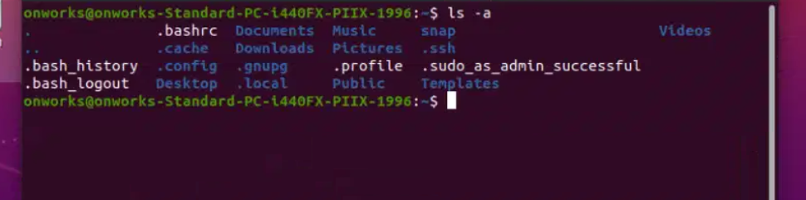

**CD :** Used to change directories in linux, below cd to Documents is shown



**Cd / :** changes directory to root



**Cd :** changes present directory to home directory



**Touch :** to create a file in linux

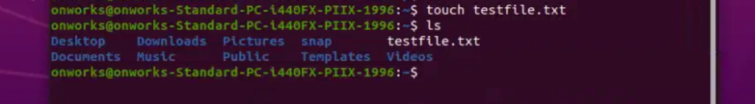

**Stat <file name > :** shows the timestamp of file (here it’s testfile.txt)

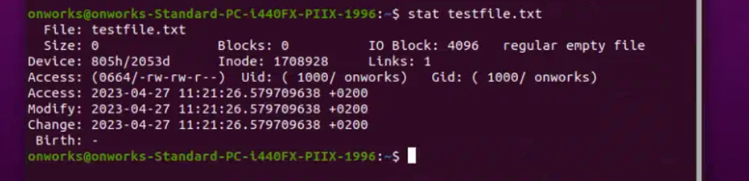

**Cat :** Shows content of a file

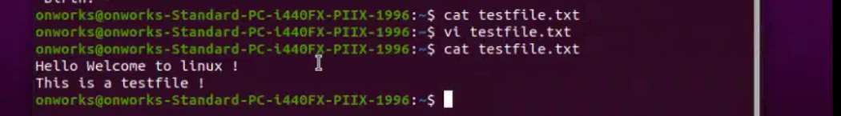

Here we’ve saved contents of testfile and testfile2 and output to new file out.txt, we can see output contents of multiple files

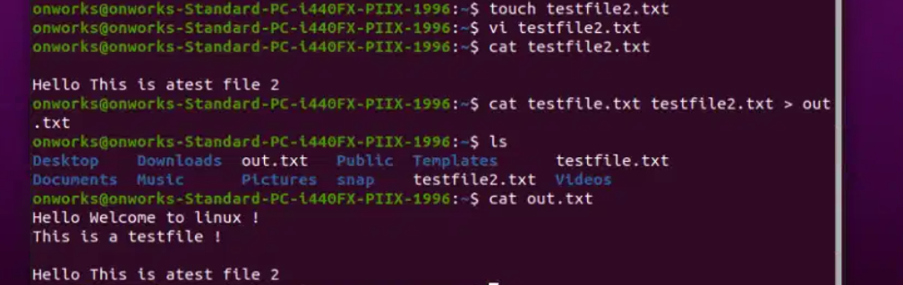

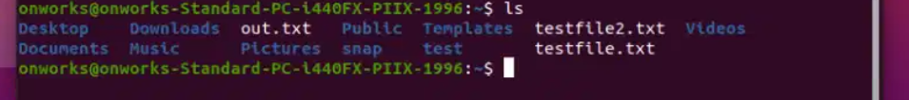

**Rm :** used to remove a file

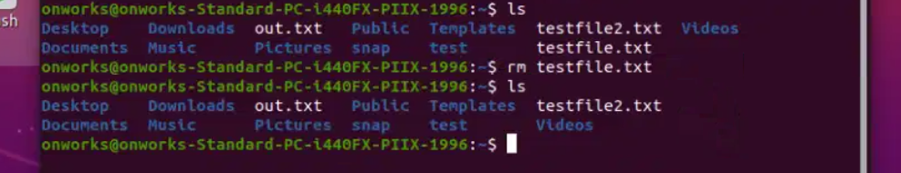

Here we can see the testfile is removed from directory

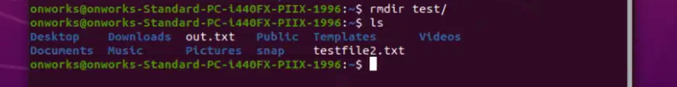

**Mkdir :** make a new directory <new>

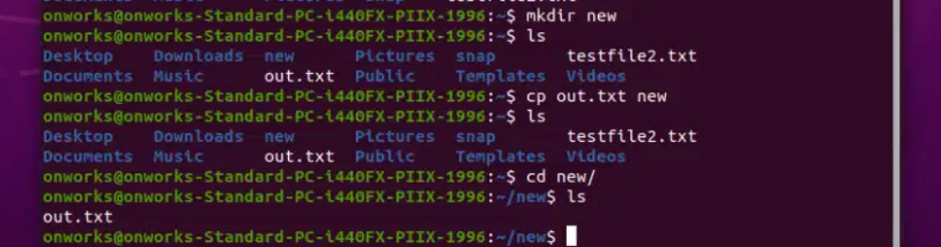

Copied **out.txt** to **new** directory

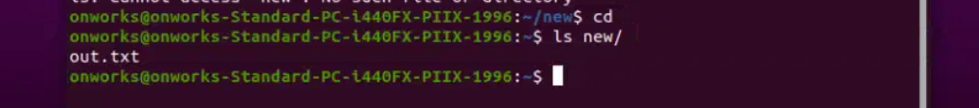

**Cp -r :** recursive copy copies entire folder to new directory

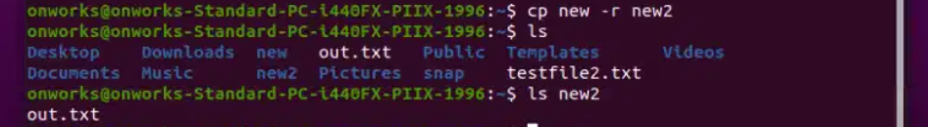

**Mv :** move files around the computer and also we can rename files and directories inside specific directory

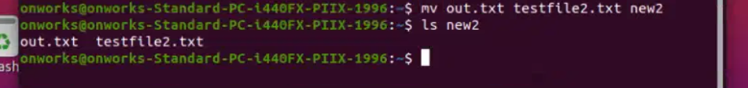

**Ls <directory name> :** lists contents of mentioned directory

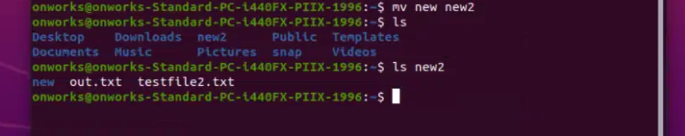

**Head <filename > :** Prints first ten lines of a file

**Tail <filename >** : Prints last ten lines of a file

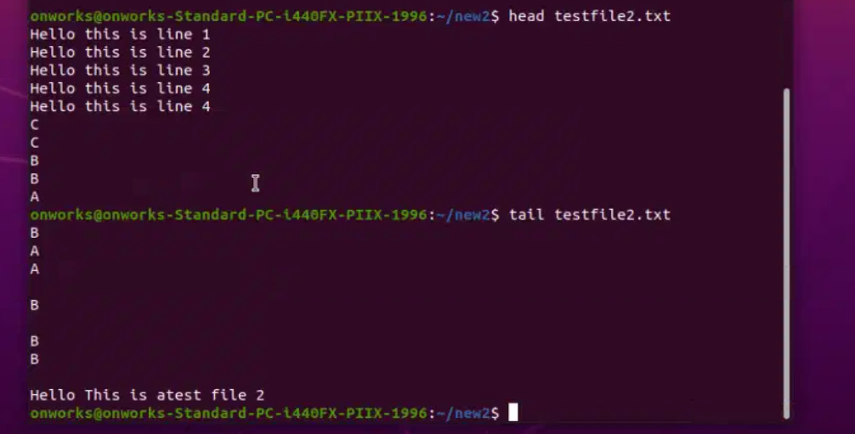

**Uname:** means unix name , here its linux so shows “Linux” , and uname -a shows detailed info about linux

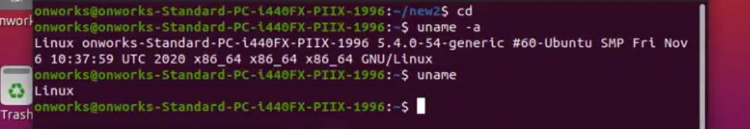

**History :** shows list of executed commands

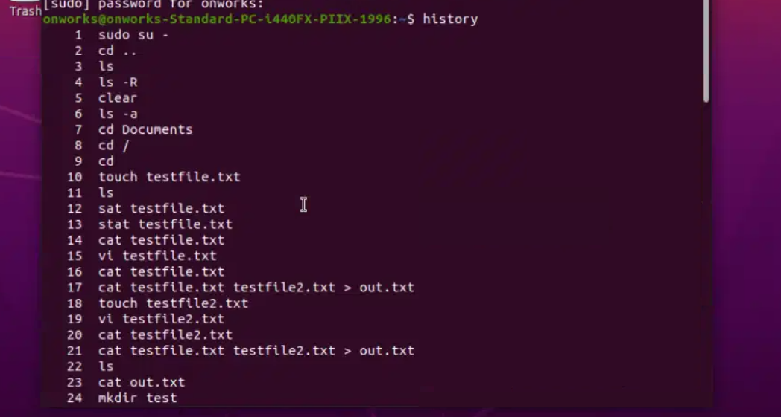

Grep: this command is used to search for string in given files , here we searched for “is” in out.txt

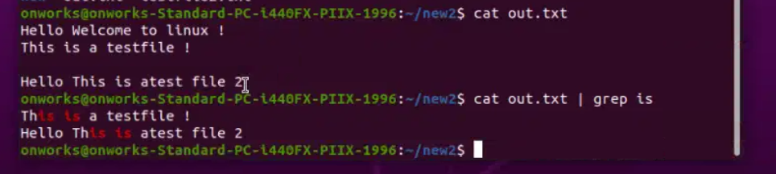

**Man:** Man command is used to find complete user manual of any specific command

Here we searched for man <grep>

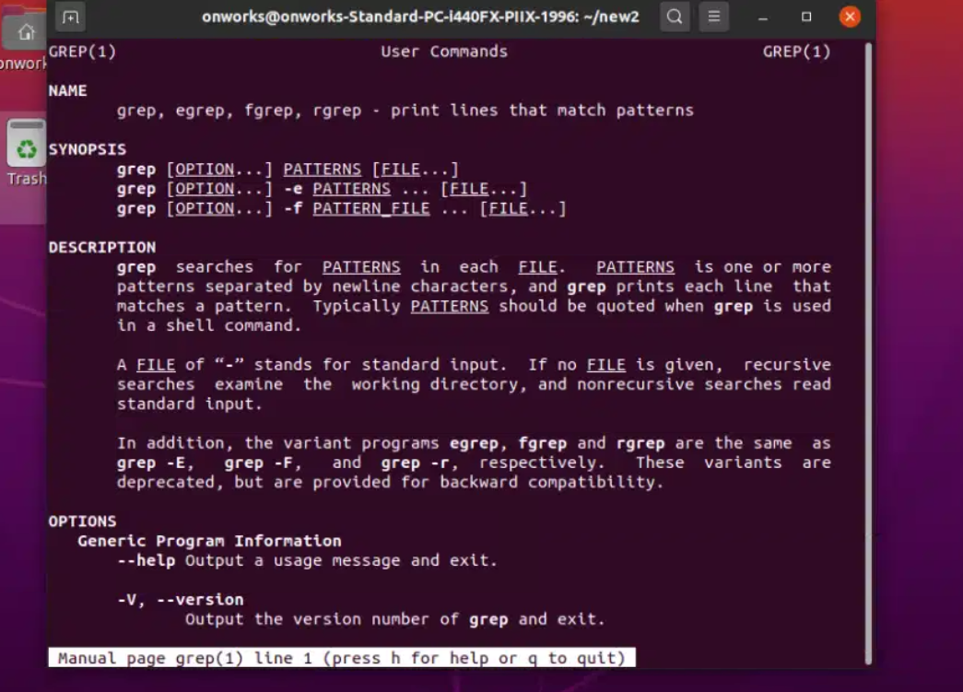

**Ps :** ps command is used to get list of process

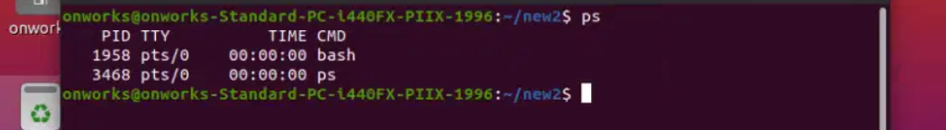

**Hostname:** prints hostname in terminal



**W:** w display’s users that are currently logged into the system

